­user management

1. Create user "nikhil" with home directory set as "/home/nikhil"

On most Linux distributions, when creating a new user account with useradd, the user’s home directory is not created.

Use the -m (--create-home) option to create the user home directory as /home/username:

sudo useradd -m username

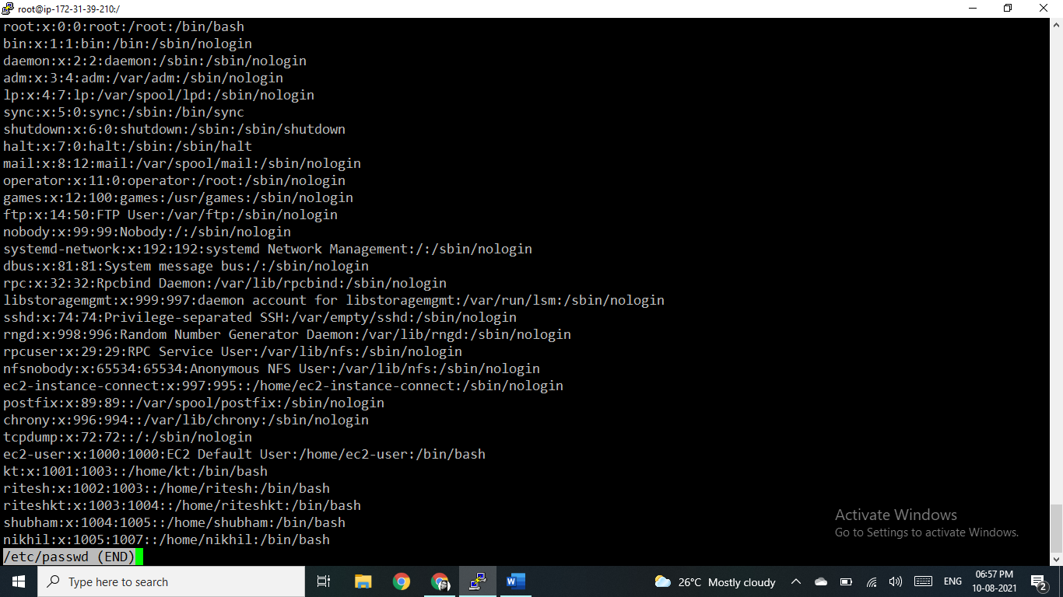

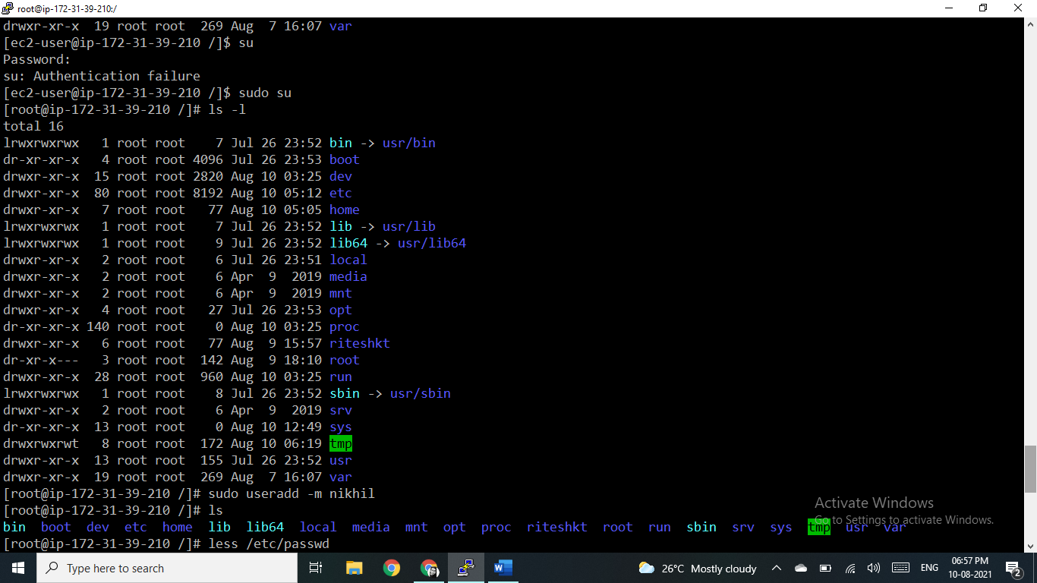

1. nikhil user should have "/bin/sh" shell for his environment

By default, the new user’s login shell is set to the one specified in the /etc/default/useradd file.

In some distributions the default shell is set to /bin/sh while in others it is set to /bin/bash.

The -s (--shell) option allows you to specify the new user’s login shell.

[root@ip-172-31-39-210 /]# useradd -m -s /bin/sh Nikhil

-m for home directory and

-s for shell, in which shell user environment will be created

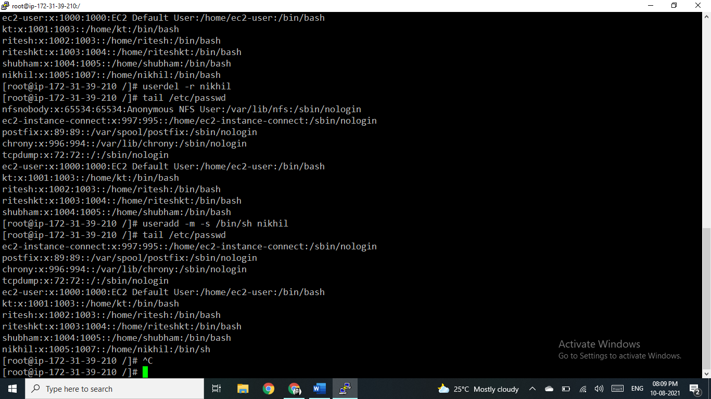

b) His password should expire in 9 days and 2 days before password expiry, he should get warning. User account must expire in 1 month from creation date.

sudo chage -E 2021-09-10 nikhil

chage -l Nikhil

Last password change : Aug 10, 2021

Password expires : never

Password inactive : never

Account expires : Sep 10, 2021

Minimum number of days between password change : 0

Maximum number of days between password change : 99999

Number of days of warning before password expires : 7

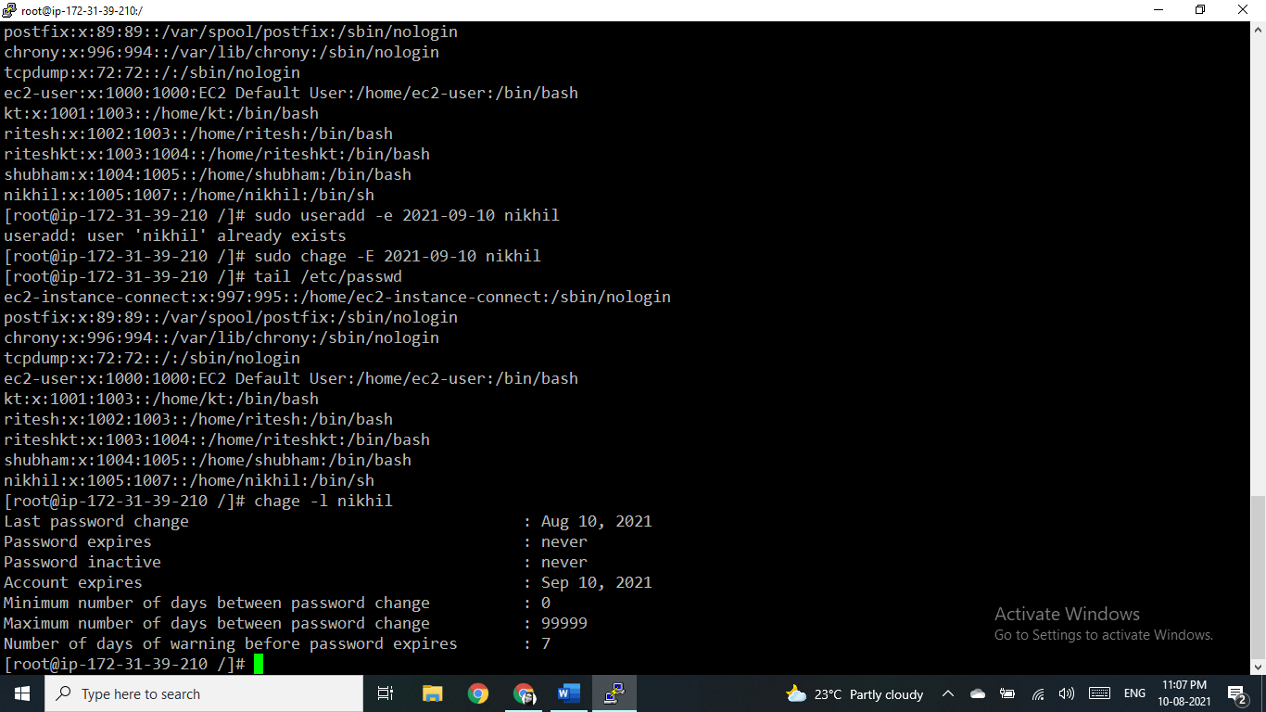

Set warning for the user before password expires

[root@ip-172-31-39-210 /]# sudo chage -W 2 nikhil

[root@ip-172-31-39-210 /]# sudo chage -l Nikhil

Account expires

[root@ip-172-31-39-210 /]# sudo chage -E 2021-09-10 nikhil

[root@ip-172-31-39-210 /]# sudo chage -l Nikhil

Minimum number of days between password change

[root@ip-172-31-39-210 /]# sudo chage -m 9 nikhil

[root@ip-172-31-39-210 /]# sudo chage -l Nikhil



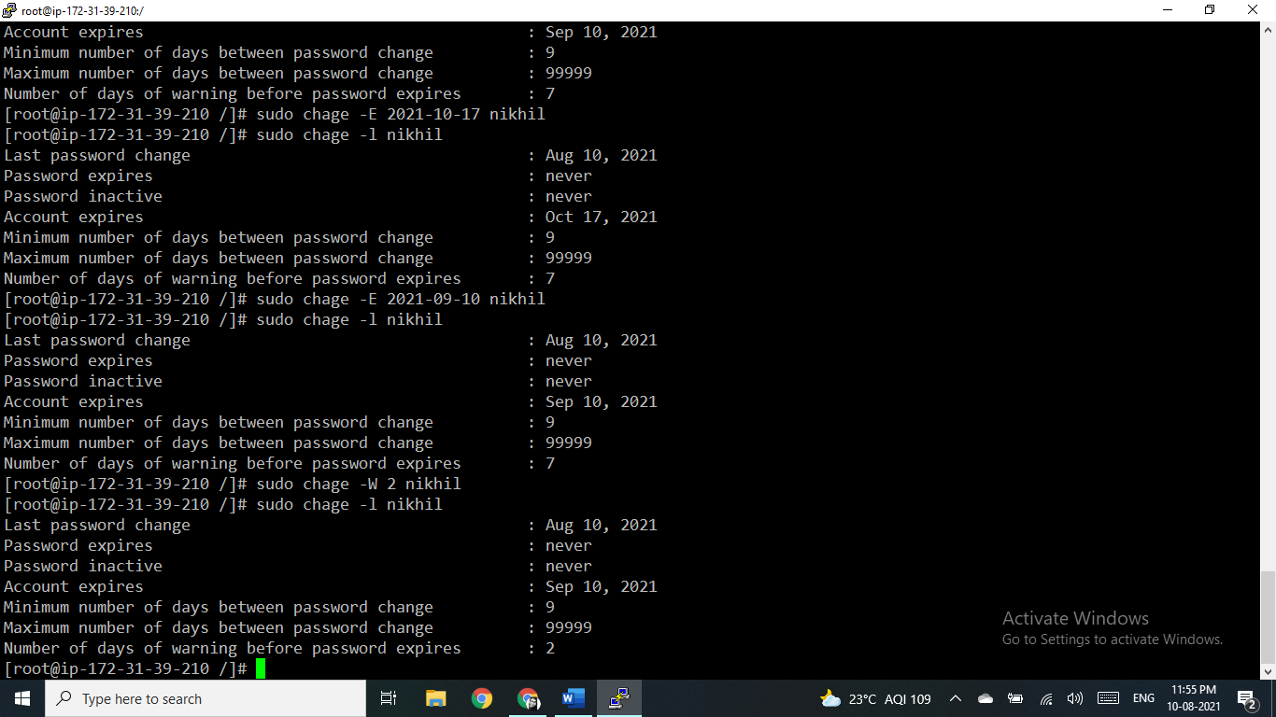

Give him root privileges to start/stop cron daemon. - Explore “sudoers”

### **Start/Stop/Restart cron service in Redhat/Fedora/CentOS**

**Start cron service**

# service crond start

**Stop cron service**

# service crond stop

**Restart cron service**

# service crond restart

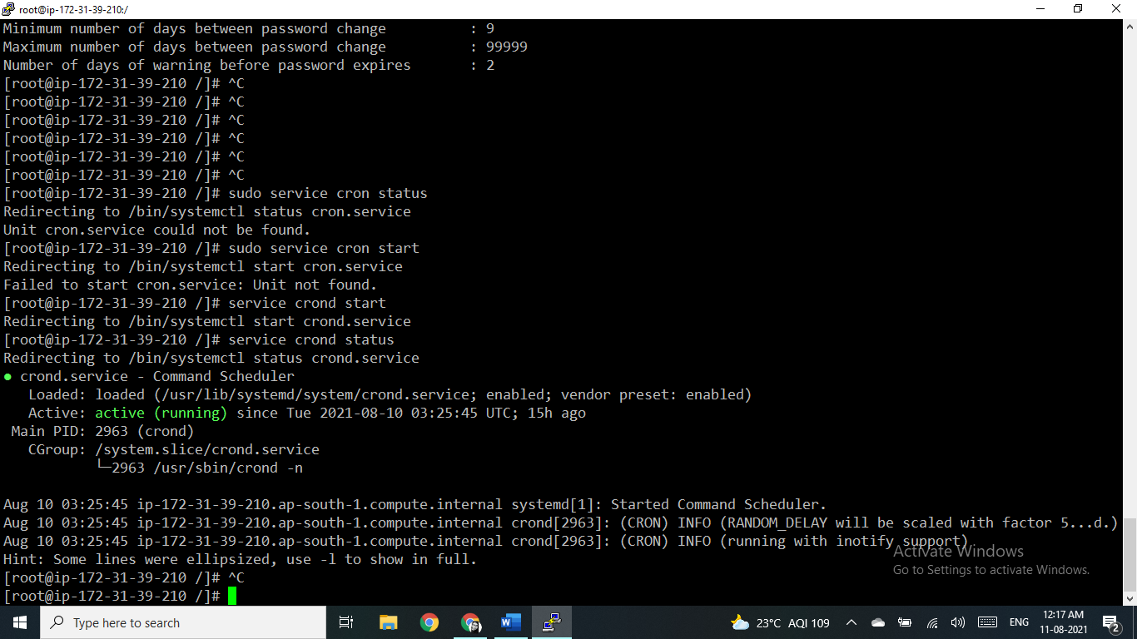

1. Inside folder "/" , create new home directory as "nikhil" (/nikhil) and setup this folder as a home directory for user "nikhil"

[root@ip-172-31-39-210 /]# mkdir nikhil

[root@ip-172-31-39-210 /]# ls -l

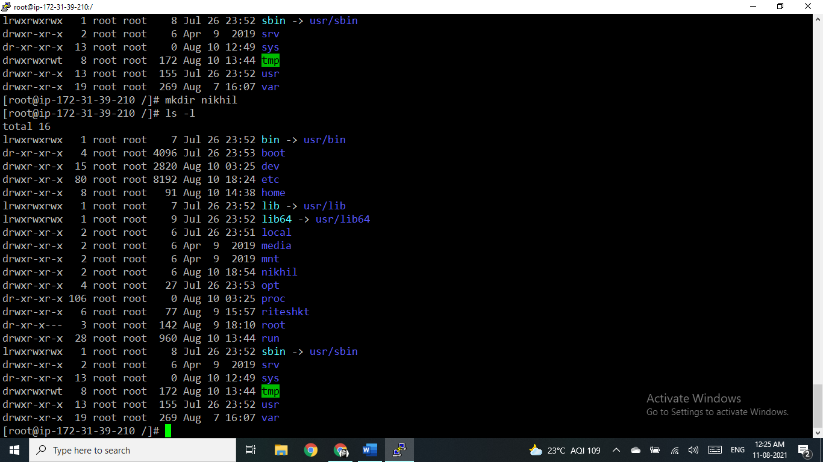

and setup this folder as a home directory for user "nikhil"

[root@ip-172-31-39-210 /]# sudo usermod -m -d /usr/nikhil Nikhil

[root@ip-172-31-39-210 /]# tail /etc/passwd

